**PROJECT TITLE**

**DIGITAL NATURALIST-AL ENABLE TOOL FOR BIODIVERSITY RESEACHERS**

**1.INTRODUCTION**

**1.1 PROJECT OVERVIEW**

**The increasing handiness of digital images, coupled with sophisticated unreal inteligence techniques for image assortment, presence an exciting oppurtunity for biodiversity researcher to create new datasets of species observance.We investicated whether an AI plant species classifier could extract previously unexploited biodiversity data from social media photos.We found over 60,000 giolocated images tagged with the keyboard "flower" across an urban and rural location in the UK and classified these using AI, reviewing these appointment and assesing the representativeness of images.**

**1.2 PURPOSES**

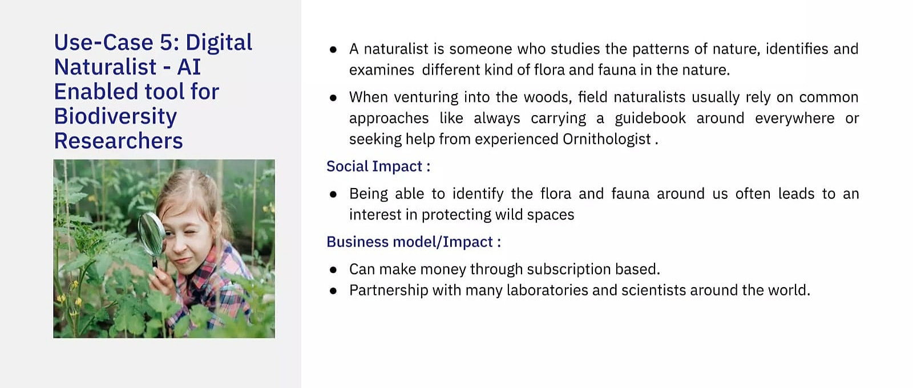

**2.LITERATURE SURVEY**

**2.1 Existing problem**

**Here ,We will take a look at all the previous solution, attempts and performance to the digital naturalist coating or anything that is atleast vaguely related to it.**

**2.1 REFERENCE**

**1. TITLE OF PAPER: Digital naturalism: Interspecies performative tool making for embodied science.**

**AUTHOR: Andrew Quitmeyer**

**METHOD: Encounter phenomenon**

**Experiential Assay**

**try out**

**Analysis**

**Review**

**Data dispersion**

**2. TITLE OF PAPER: Learning schooling behaviour from observance.**

**AUTHOR: Brian Hrolenok and Tucker Balch**

**METHOD: Learning fish schooling**

**Fish sensor features**

**Fish actuators**

**Learning**

**pretense of learned behaviour**

**3. TITLE OF PAPER: From digital nature hybrids to digital naturalists: Reviewing Nature connection through arts applied science and outdoor action.**

**AUTHOR: L.Ewards**

**A.Darby**

**C.Dean**

**METHOD: debut**

**Background**

**Design Lens**

**Using the critical lens to establish design guidelines**

**Artifacts**

**2.3 PROBLEM STATEMENT DEFINITION**

**Improve responce time**

**Easy communication**

**Has to achieve all the demand**

**Accessible by all coevals**

**Cost must be considered in account**

**Benifit the researcher**

**3. IDEATION & PROPOSED SOLUTION**

**3.1 EMPHATHY MAP CANVAS**

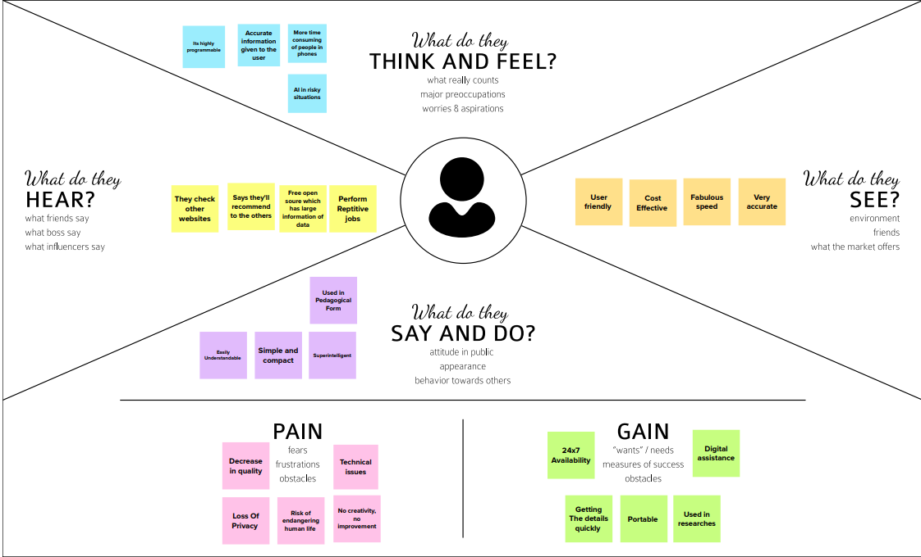

**3.2 IDEATION & BRAINSTORMING**

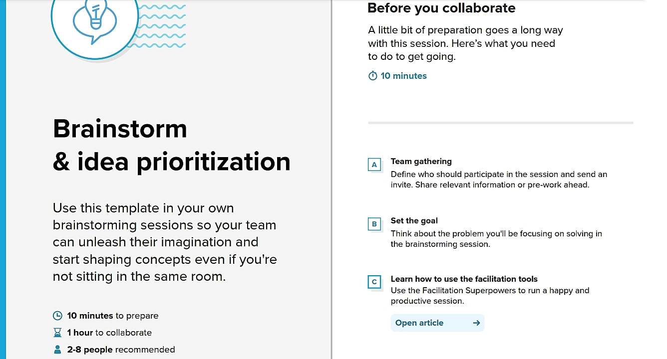

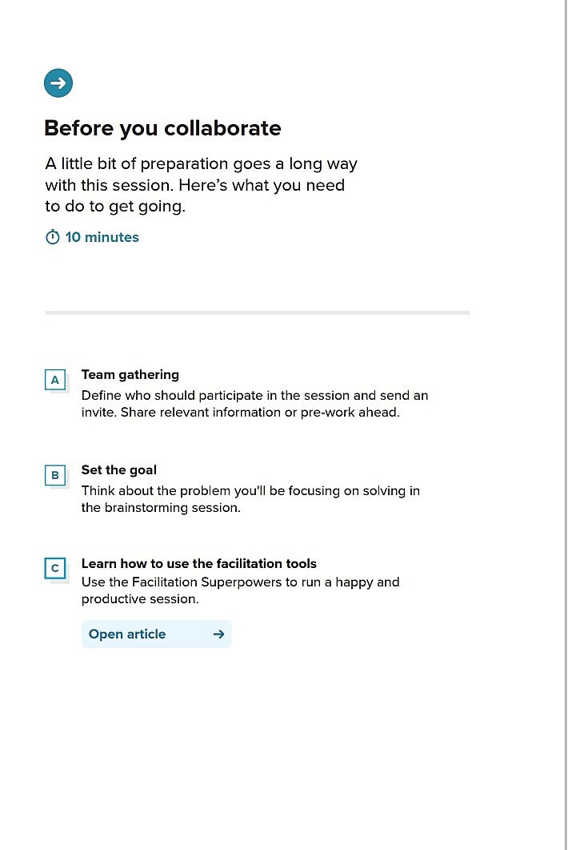

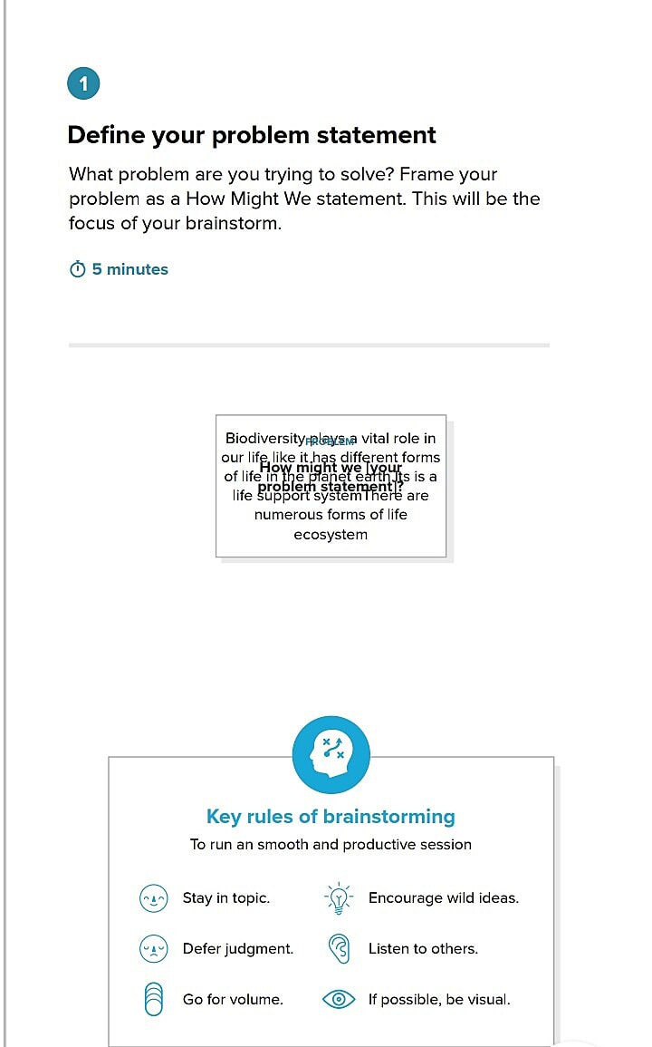

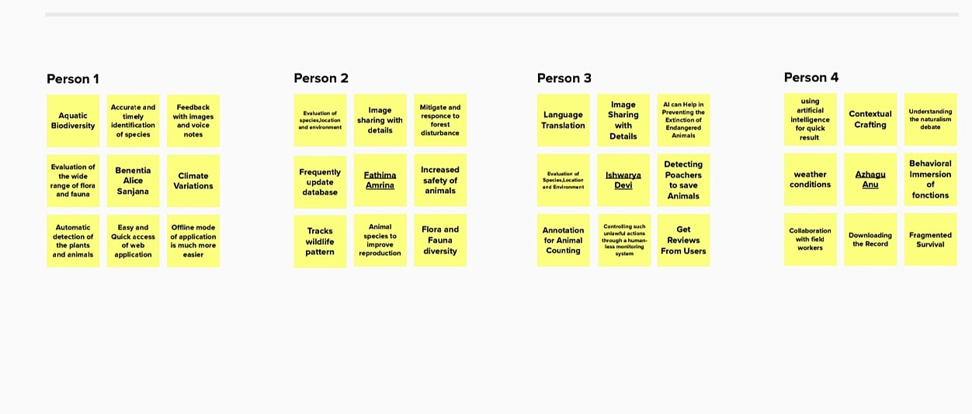

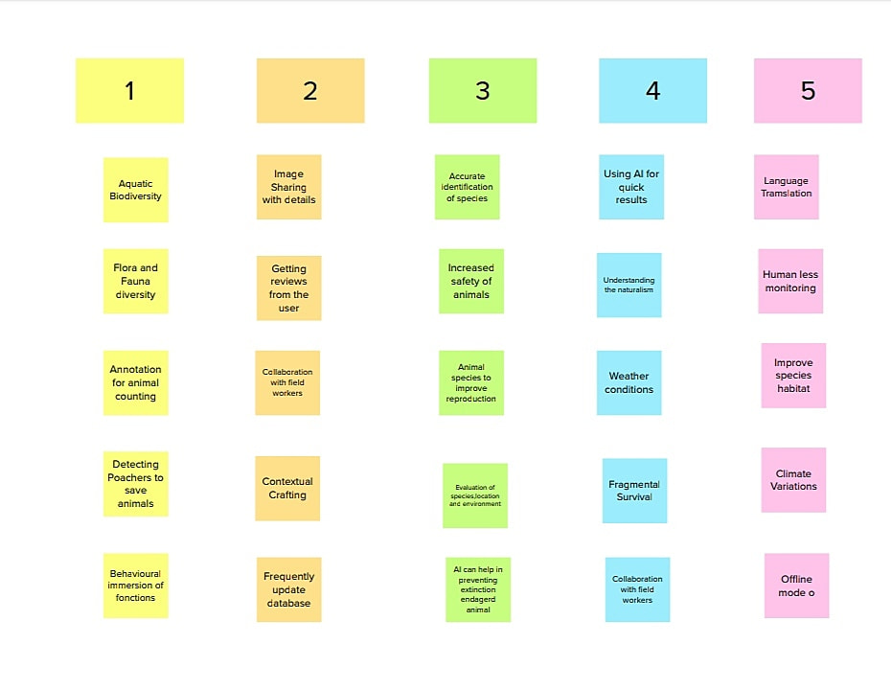

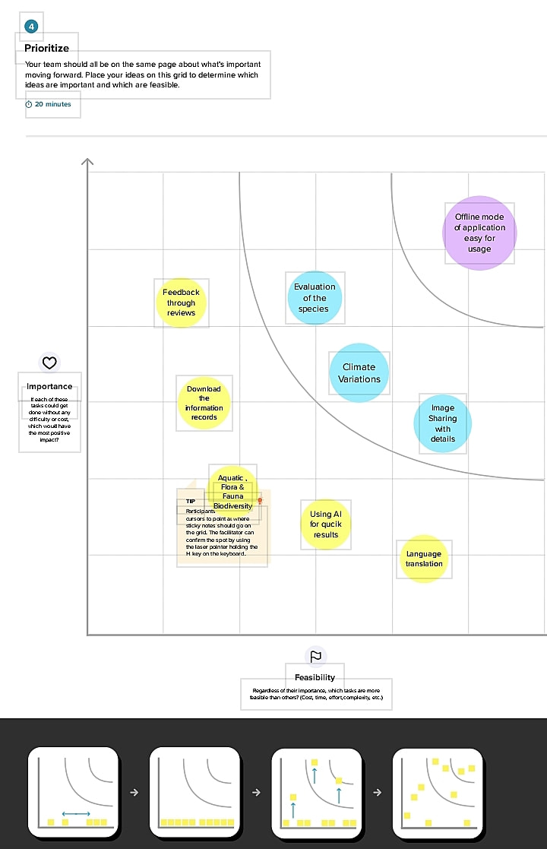

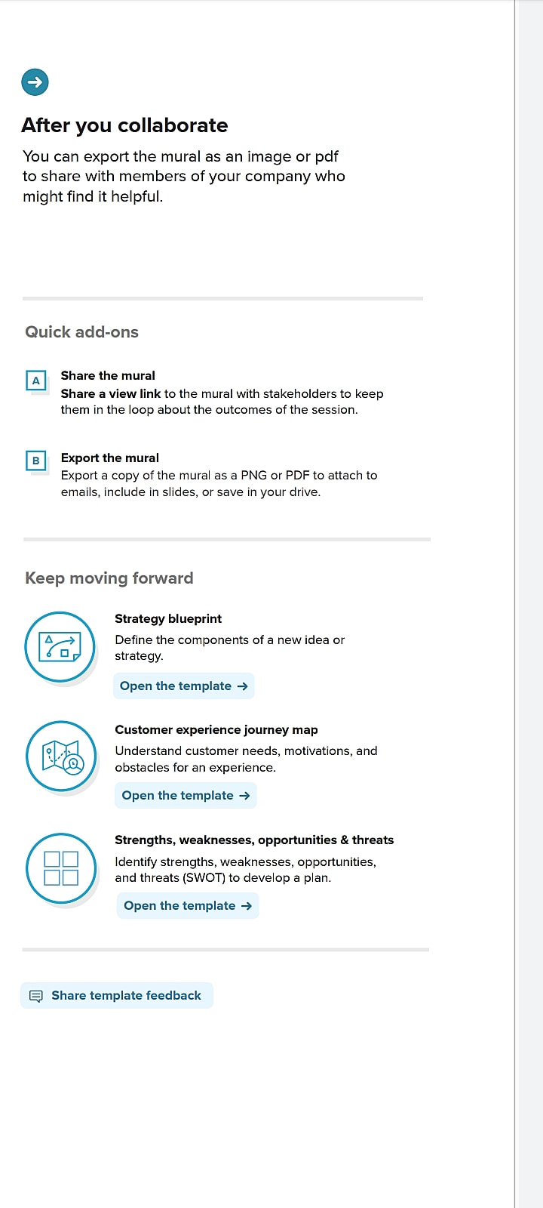

**3.3 PROPOSED SOLUTION**

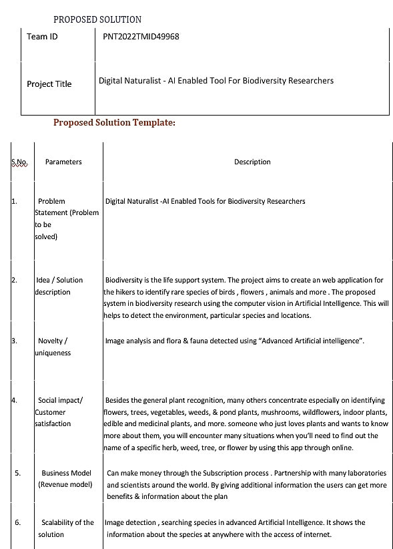

**3.4 PROBLEM SOLUTION FIT**

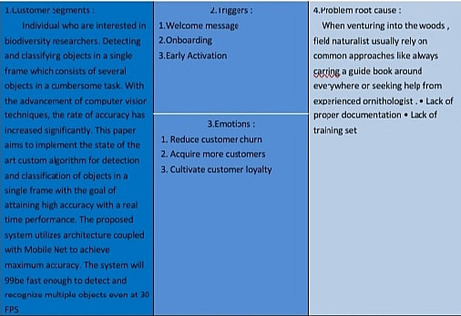

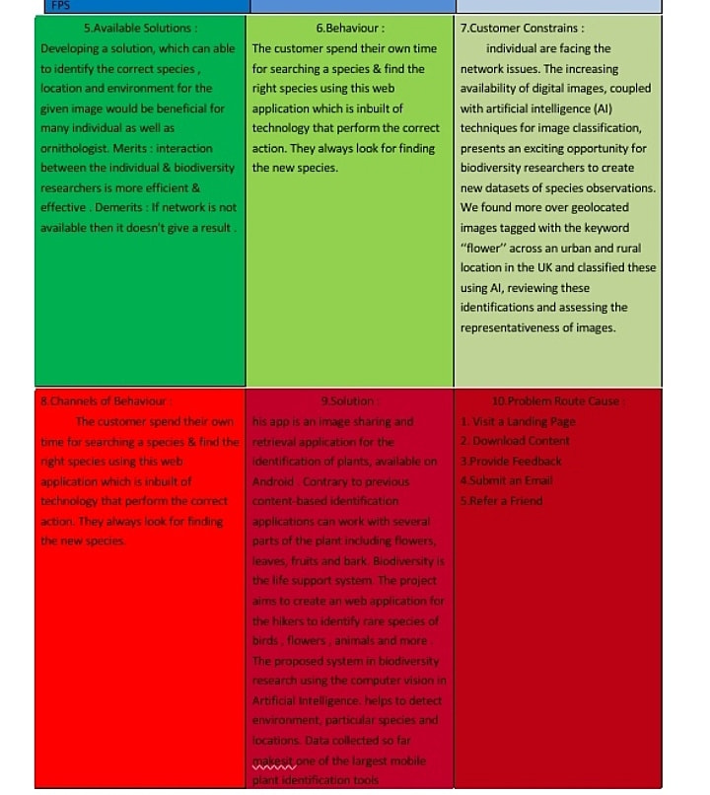

**4. demand ANALYSIS**

**4.1 FUNCTIONAL REQUIREMENT**

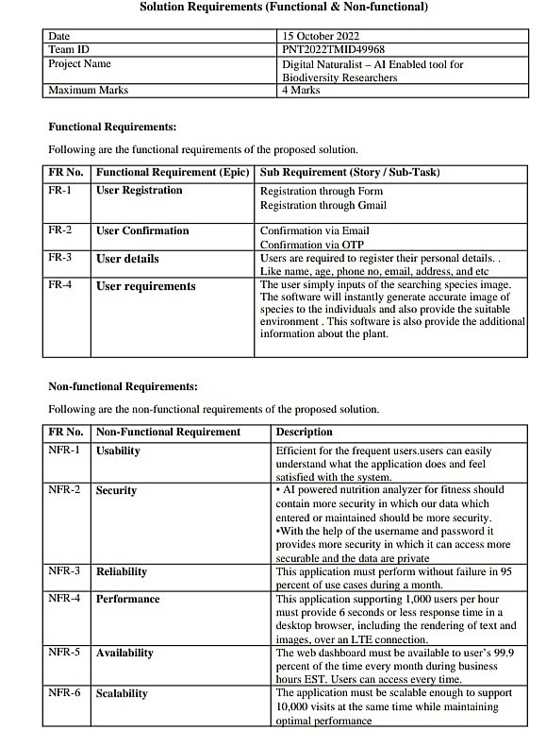

**5. PROJECT DESIGN**

**5.1 DATA FLOW DIAGRAM**

**A Data flow diagram is a traditional visual delegacy of the info flows within a system. A neat and clear DFD can depict the right amount of the system demand graphically. it shows how data enter and leaves the system,what changes the info and where data is stored.**

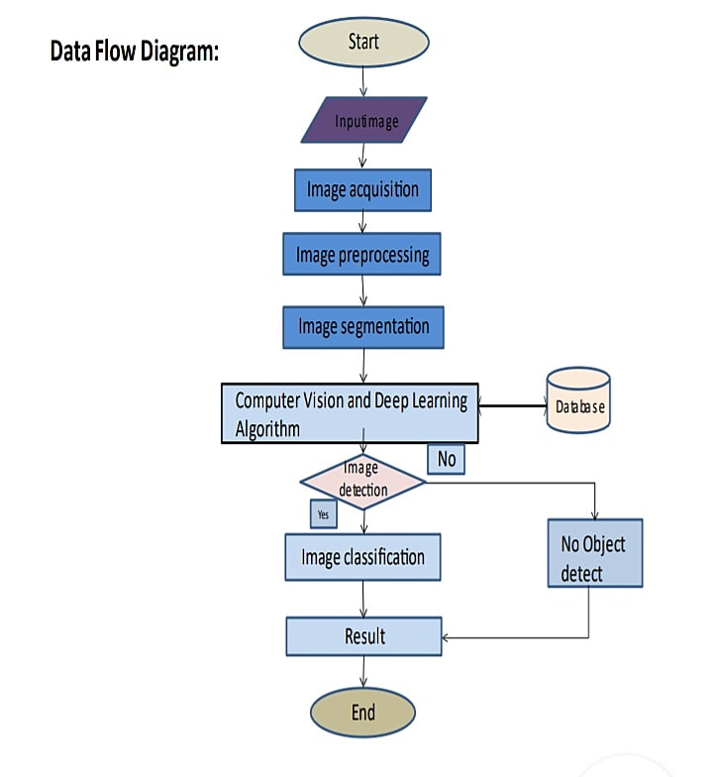

**5.2 SOLUTION AND TECHNICAL ARCHITECTURE**

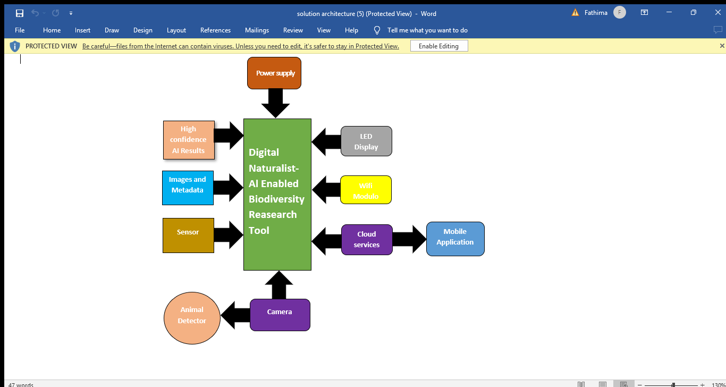

TECHNICAL ARCHITECTURE

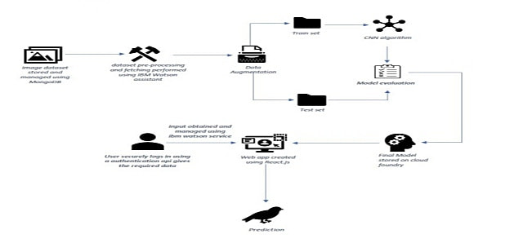

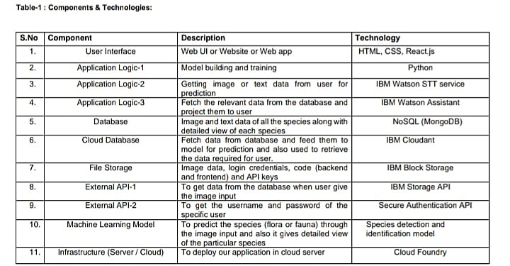

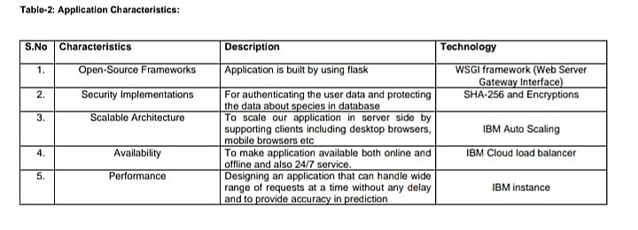

**5.3 USER STORIES**

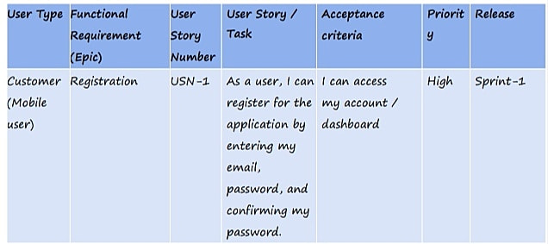

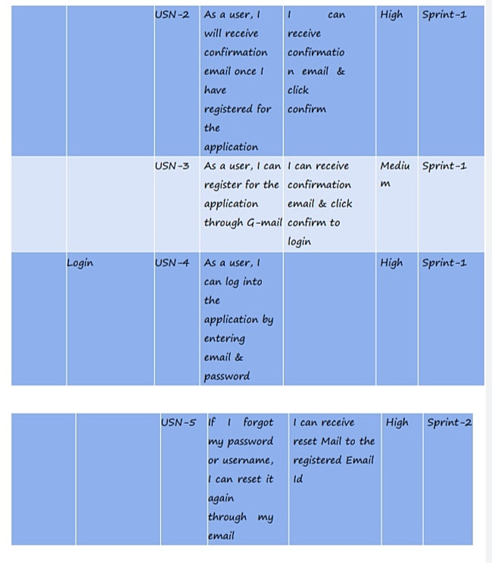

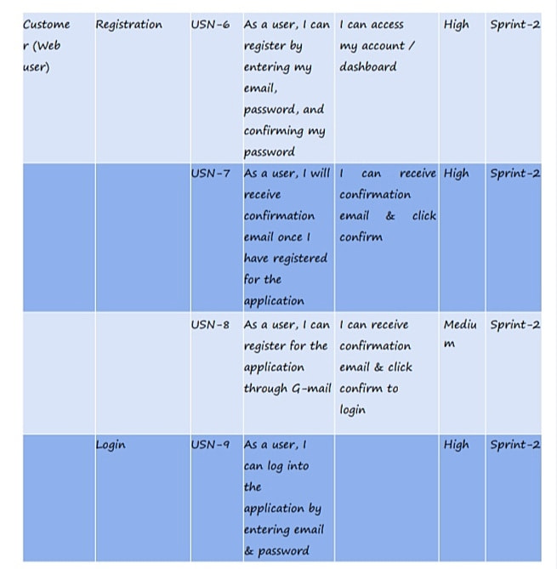

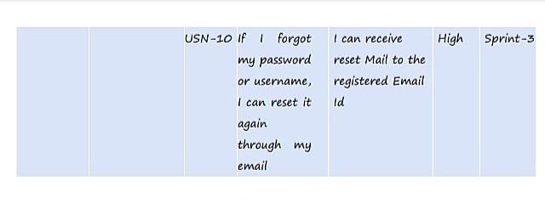

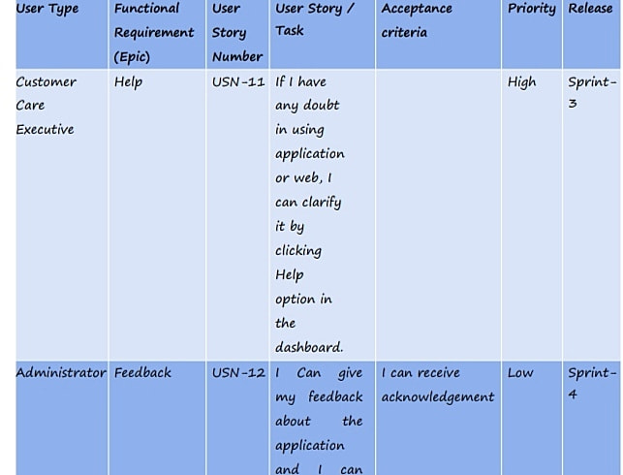

**6.PROJECT PLANNING AND SCHEDULING**

**6.1 SPRINT PLANNING AND estimate**

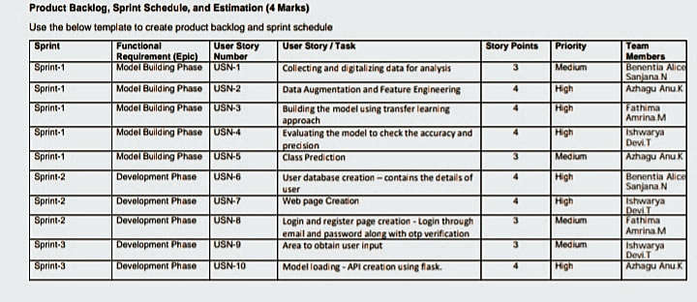

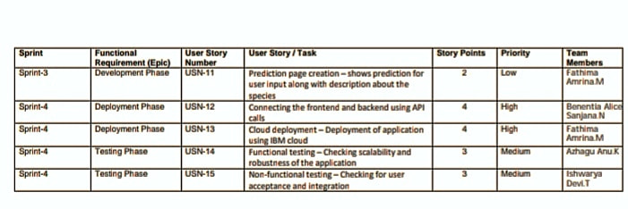

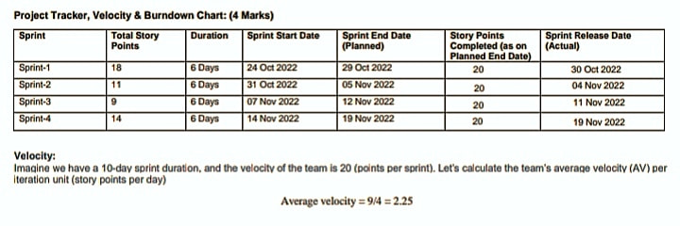

**BOUNDARY CHART**

**Boundary chart is a graphical delegacy of work left to do versus time.it is often used in agile software growth methodologies such as scrum. however,burndown chart can be applied to any project containing measurable progress over time.**

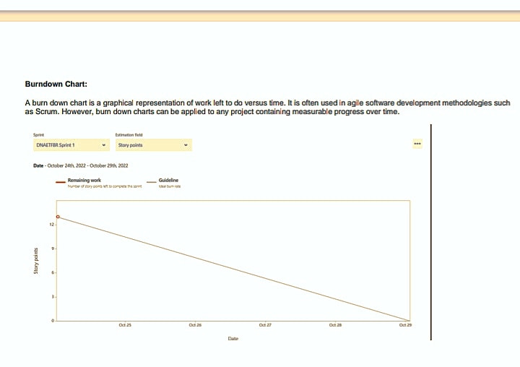

**6.3 REPORT FROM JIRA**

**FILE 1**

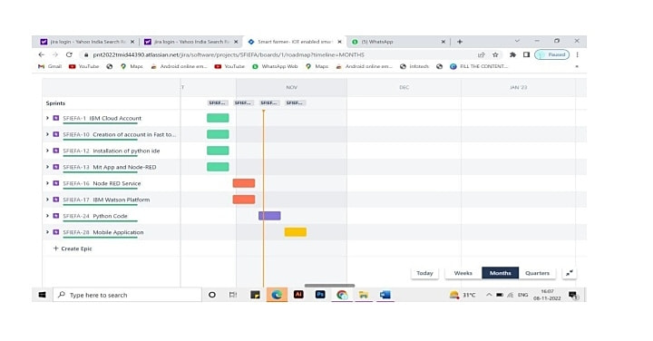

**FILE 2**



**FILE 3**



**FILE 4**



**ADVANTAGES AND DISADVANTAGES**

**ADVANTANGES**

**1.More accurate prediction of natural disasters**

**2.Predict magnitude of earthquake**

**3.Detect earthquake with speed and accuracy on seismological data**

**4.Sum-up good result as compared to the already existing techniques**

**DISADVANTAGE**

**1.Limited statistical parameter for prediction**

**2.Work on only for prediction to seismic dataset**

**3.Limited parameter used for parameter**

**4.Limited for only early stages of natural disaster**

**CONCLUTION**

**Many researchers have attempted to use different deep learning methods for detection of natural disasters , however, the detection of natural disaster by using deep learning techniques still faces various issues due to noise and serious class imbalance problems.To address these problem,we proposed a multi layer deep convolutional neural network for detection and intencity classification of natural disaster.**

**It is important to understand AI and gathered data from various species to create a database for the animal detection.**

**SCOPE OF STUDY**

**The role of AI technology is vast and it is sill in development**

**GITHUB LINK**

**https://github.com/IBM-EPBL/IBM-Project-11949-1659360239**

**RESULT**

